How health-care costs stopped rising

## In America and elsewhere the received wisdom has been proved wrong

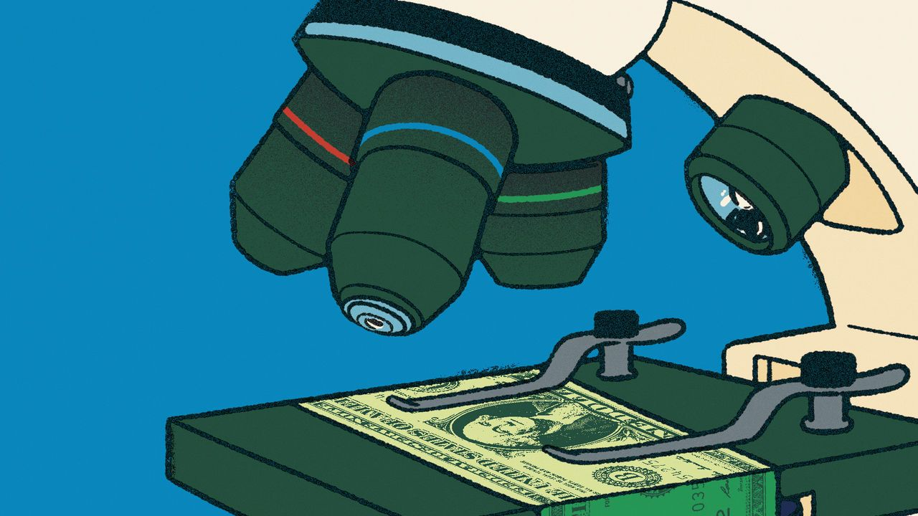

image: alberto miranda

Oct 26th 2023 | SAN FRANCISCO

Listen to this story. Enjoy more audio and podcasts on [iOS](https://economist-app.onelink.me/d2eC/bed1b25) or [Android](https://economist-app.onelink.me/d2eC/7f3c199).

For a long time, health care was eating the world. From 1950 to 2009 American spending on hospitals, medics and the like rose from 5% of gdp to 17%. Between the late 1970s and the mid-2010s British public spending on health rose by 4% a year in real terms, much faster than the economy’s growth of 2% a year. From 1980 to 2010 overall French prices rose by 150%; the price of caring for a sick or old person rose by 250%. Among economists, the proposition “health care’s share of gdp rises” was almost as close to an iron law as “free trade is good” or “rent controls do not work”.

长期以来，医疗保健一直在吞噬世界。从1950年到2009年，美国在医院、医疗人员等方面的支出从国内生产总值5%上升到17%。从20世纪70年代末到2010年代中期，英国在公共医疗上的实际支出年增长率为4%，远远快于2%的经济增长率。从1980年到2010年，法国的整体物价上涨了150%；照顾病人或老年人的价格上涨了250%。在经济学家眼中，"医疗保健占国内生产总值的比例上升"的观点几乎可以被视为一条铁律，就像"自由贸易有利"或者"租金控制无效"一样。

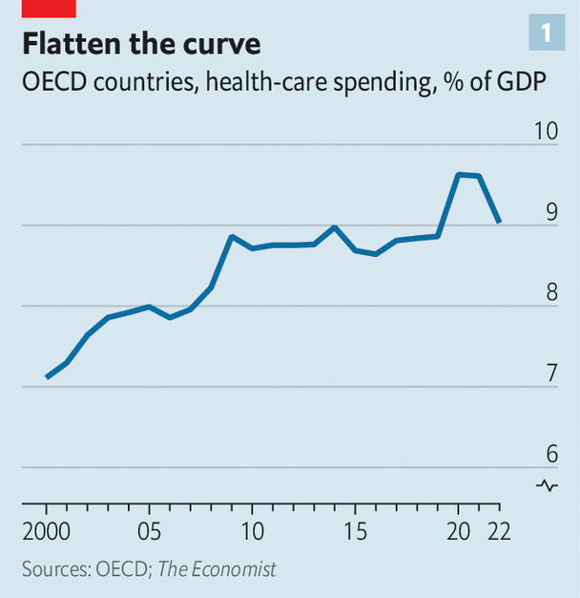image: the economist

The iron has now melted. Even as populations age, and as the world continues to deal with the fallout from the covid-19 pandemic, health care is no longer taking over the economy. Across the rich world health care’s share of gdp jumped in 2020 and 2021, because of a combination of pandemic-related spending and lower gdp. However, it has since fallen back to close to its level in 2008 (see chart 1). Because of this “flattening of the curve”, health spending today is somewhere in the region of $2trn below its pre-2009 trend.

这个铁律已经被打破。尽管人口老龄化，世界依然在应对新冠疫情留下的后果，但医疗保健不再占据经济的主导地位。在富裕国家，由于疫情相关支出和国内生产总值下降的双重因素，医疗保健在2020年和2021年的国内生产总值中的占比增加。然而，医疗保健支出已经回落至接近2008年水平（见图表1）。由于这种“曲线平缓”， 如今，医疗支出大约比2009年前的趋势水平低了约2万亿美元。。

In some countries the changes are still more dramatic. The ratio of health-care spending to gdp has fallen from its pre-covid peak in Australia and Sweden. In Norway it has tumbled by a remarkable 2.5 percentage points of gdp from its level in 2016. Even in America—the land of costly health care—something has changed. A new measure published by the Bureau of Economic Analysis suggests that the share of spending going on health care has been falling since before the pandemic. A widespread slowdown has never happened before. It has not even come close to happening.

在一些国家，这种变化更加戏剧性。澳大利亚和瑞典的医疗保健支出与国内生产总值的比例已经从新冠疫情前的峰值下降。挪威的情况更为引人注目，医疗保健支出与国内生产总值的比例自2016年以来已经下降了惊人的2.5个百分点。就连在以昂贵医疗保健而闻名的美国，也发生了一些变化。美国经济分析局发布的一项新指标显示，医疗保健的支出份额自疫情爆发前就一直在下降。这种广泛的减缓是前所未有的，甚至没有接近发生过的情况。

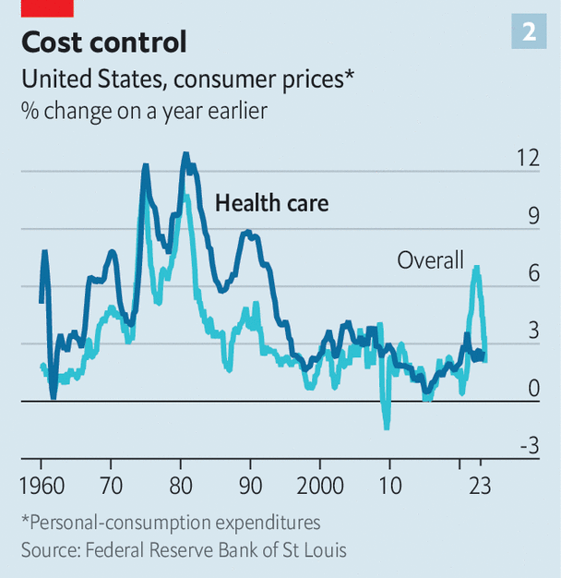image: the economist

Inflation in the global health-care industry, which once looked Argentine, now looks rather more normal. Consider a broad measure of American health-care prices, which includes not only things purchased directly by consumers but also those paid for on their behalf, such as by insurers. From the 1970s to the 2000s annual inflation almost always exceeded the average (see chart 2). But in around 2010 that relationship flipped—and much the same is true elsewhere. Relative to the “gdp deflator”, an economywide measure of inflation, the deflator in health and social care across the rich world has pretty much stopped rising. In the 1990s Japanese health inflation soared relative to average prices, but has fallen since 2015. In the French health-and-social-care sector, once dreadful at cost control, prices now grow in line with the economywide average.

全球医疗保健行业的通胀，曾经看起来像阿根廷那样不正常，现在看起来更加正常。以美国医疗保健价格的广泛指标为例，该指标不仅包括消费者直接购买的物品，还包括保险公司代表他们支付的费用。从20世纪70年代到21世纪初，每年的通货膨胀率几乎总是超过平均水平（见图表2）。但大约在2010年左右，这种关系发生了逆转，其他地方也是如此。与经济范围内的通胀衡量指标“GDP平减指数”相比，富裕国家的医疗和社会保健部门的平减指数几乎停止上涨。在20世纪90年代，相对于平均价格，日本的医疗保健通胀率飙升，但自2015年以来已经下降。法国的医疗保健和社会保障部门曾经在成本控制方面糟糕不堪，但现在的价格增长趋势与整体经济平均水平保持一致。

To understand the significance of this development, consider some earlier warnings. “Put simply,” said President Barack Obama in 2009, “our health-care problem is our deficit problem.” In 2017 Britain’s fiscal watchdog cautioned that “excess cost growth” in health could add an additional 90% of gdp to Britain’s debt by the 2060s. Such statements now look a little outlandish, but few people saw this curve-flattening coming. What prompted it?

为了理解这一发展的重要性，可以回顾一些早期的警告。奥巴马总统在2009年表示：“简单地说，我们的医疗保健问题就是我们的财政赤字问题。”2017年，英国的财政监管机构警告称，医疗保健中的“过度成本增长”可能会在2060年代给英国的债务增加额外的国内生产总值的90%。这样的说法现在看起来有些离奇，但很少有人预见到这种曲线平缓的趋势。是什么促使了这种变化呢？

Begin with supply-side factors. Falling health-care inflation is consistent with rising health-care productivity. Economists typically think productivity gains in health care are difficult to come by because the service is labour-intensive. It is, for example, unrealistic to expect a phlebotomist to draw a blood sample 3% faster, year after year. Typically this results in “cost disease”, where spending must rise over time in order for the service merely to stand still. After all, even if phlebotomists do not get more efficient, they still expect a pay rise every now and then—without them they may be enticed to other sectors. William Baumol, who identified this phenomenon, worried about health-care spending swallowing up an ever-larger share of gdp.

从供给方面来看，医疗保健通胀的下降与医疗保健生产力的提高是一致的。经济学家通常认为，在医疗保健领域实现生产力的增长是困难的，因为该服务业是劳动密集型的。例如，期望护血师每年将血液样本提取速度提高3%是不现实的。这通常导致了“成本疾病”，即为了维持服务水平的稳定，支出必须随着时间的推移而增加。毕竟，即使护血师没有变得更高效，他们仍然期望偶尔获得加薪，否则他们可能会被其他行业吸引。威廉·鲍莫尔曾经担忧医疗保健支出不断蚕食国内生产总值的比例越来越大。

At the same time, it never seemed plausible that health care was entirely immune to productivity gains. Even for an occasional patient it is blindingly obvious that health systems are ravaged by inefficiencies: paper-based forms instead of digital ones; hours spent filing insurance claims; different parts of the system not talking to one another. Meanwhile, some systems do seem to have improved. According to America’s Bureau of Labour Statistics, labour productivity in health care and social assistance fell by 13% between 1990 and 2000, but then made up all the lost ground from 2000 to 2019. In Britain, a study found that staff in the National Health Service (nhs) provided 17% more care pound for pound in 2016 than they did in 2004, compared with productivity growth of 7% in the economy as a whole. All this may have helped keep cost growth under control.

同时，医疗保健领域从未完全摆脱生产力提升的可能性。即使对于偶尔就诊的患者来说，医疗系统的低效率问题显而易见：纸质表格代替数字化表格，花费时间处理保险索赔，不同部门之间缺乏有效沟通。与此同时，一些系统似乎已经有所改善。据美国劳工统计局数据显示，从1990年到2000年，医疗保健和社会援助领域的劳动生产率下降了13%，但从2000年到2019年，又成功地弥补了所有损失。在英国，一项研究发现，相较于2004年，2016年国民健康服务体系（NHS）的员工提供的护理服务比例上升了17%，而整个经济的生产力增长仅为7%。所有这些或许有助于控制成本的增长。

Another supply-side factor—technological change—may also play a role. Over the long sweep of history, innovations have tended to raise health-care spending. This is in part because they often make therapies available for conditions that were previously impossible to treat. In the 1960s, for instance, the advent of dialysis machines was quite literally a life-saver for people suffering from kidney failure. And yet in the rich world the current cost of a year of dialysis for a patient is somewhere between $40,000 and $60,000, close to these countries’ per-person gdp.

另一个供给方面的因素，即技术变革，可能也起到了一定作用。从较长的历史来看，创新往往会提高医疗保健支出。这部分原因是因为创新常常使得以前难以治疗的疾病找到了治疗方法。例如，在20世纪60年代，透析机的出现对于患有肾衰竭的人来说，确实是救命的存在。然而，在富裕国家，一年的透析治疗费用在40,000美元至60,000美元之间，接近这些国家的人均国内生产总值。

The nature of technological innovation in health care may now be changing. One possibility is that there has been a generalised slowdown in treatments that represent medical breakthroughs and are costly, such as dialysis. But this is difficult to square with a fairly healthy pipeline of drugs coming to market. Another possibility, which is perhaps more plausible, is that the type of advancements has changed, involving a shift from whizzy curative treatments to less glamorous preventive ones. There is decent evidence that the increased use of aspirin, a very low-cost preventative treatment, in the 1990s has cut American spending on the treatment of cardiovascular diseases today.

医疗保健领域的技术创新性质可能正在发生变化。一种可能是，代表医学突破且昂贵的治疗方法，如透析，其发展速度普遍放缓。但是，这与市场上不断涌现的药物相矛盾。另一种更为可信的可能性是，进步的类型已经发生了变化，从令人兴奋的治愈性治疗转向不那么引人注目但更具预防性的治疗方式。有可靠的证据表明，上世纪90年代增加使用低成本的阿司匹林进行预防性治疗，如今已经减少了美国对心血管疾病治疗的开支。

## A pill for the bill

Demand-side factors may also be keeping health-care spending in check. In America the Affordable Care Act (aca)—which was introduced in 2010, at about the time costs tailed off—tightened up the ways in which the government reimburses companies that provide treatment. The aca also made it more difficult for doctors to prescribe unnecessary treatments (seven expensive scans, perhaps, instead of one cheap one) in order to make more money.

需求方面的因素也可能在控制医疗保健支出。在美国，2010年推出的《平价医疗法案》（Affordable Care Act，ACA）的实施使得政府对提供治疗的公司的报销方式更为严格。ACA还使得医生更难以开出不必要的治疗（例如进行七次昂贵的扫描，而不是进行一次廉价的扫描）以获取更多的利润。

There are similar trends elsewhere. Following the global financial crisis of 2007-09, many cash-strapped European governments decided to reduce spending. This included limiting staff pay rises. The average basic earnings of British nurses are at least 10% lower in real terms than in 2010. Other governments have reduced spending by cutting services, sometimes to the bone. Take Greece, where the ratio of health spending to gdp is the same as it was in 2005. A paper published by the imf noted that, even before covid, the country’s health care was struggling, with “widening inequalities and large unmet needs, especially among the poor”.

其他地方也存在相似的趋势。在2007-2009年的全球金融危机之后，许多资金紧张的欧洲政府决定削减支出，包括限制员工加薪。英国护士的平均基本工资实际上比2010年至少低10%。其他政府通过削减服务来减少支出，有时甚至削减到了最低限度。以希腊为例，该国的医疗支出与国内生产总值的比例与2005年相同。国际货币基金组织发表的一篇论文指出，即使在新冠疫情之前，该国的医疗保健系统也面临困境，存在“不断扩大的不平等和贫困人口尤其严重的未满足需求”。

Other governments have saved money by replacing brand-name pharmaceutical offerings with generic equivalents. In the median European country for which there are data, generics take up 50% of the market by volume, up from 33% in 2010. After a patent on adalimumab, which is often known as “Humira” and is used to treat rheumatoid arthritis and other conditions, expired in 2018, the nhs saved around £150m ($200m) a year by bulk-buying non-brand versions of the drug.

其他政府通过替换品牌药物为非专利等效药来节省开支。在具备数据的中位欧洲国家中，非专利药物的市场份额从2010年的33%增长至50%。在2018年，用于治疗类风湿性关节炎和其他疾病的药物阿达木单抗（通常被称为“Humira”）专利过期后，英国国民保健服务（NHS）通过批量采购非品牌版本的药物每年节省约1.5亿英镑（2亿美元）。

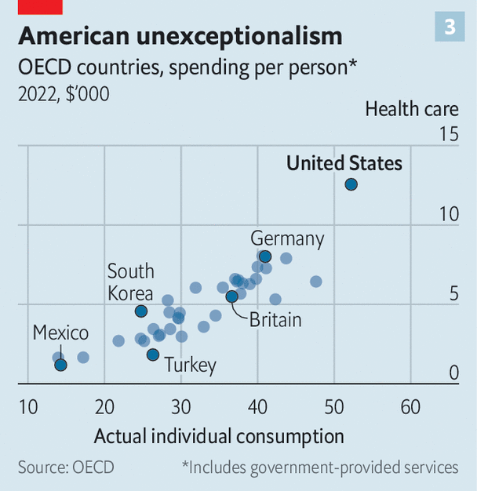image: the economist

Another demand-side factor relates to overall economic growth. Health care is a “superior good”. When people get a dollar richer, they want more than a dollar more in health care—maybe demanding, say, mental-health care in addition to more traditional life-saving treatments. Across countries there is a strikingly strong relationship between prosperity and spending on health, even in places where the government provides the bulk of the health care (see chart 3). Americans spend so much on health because they are so much richer than almost everyone else.

另一个需求方面的因素与整体经济增长有关。医疗保健是一种“高级商品”。当人们财富增加一美元时，他们希望在医疗保健上花费超过一美元的增加，可能会要求除了传统的救命治疗外，还包括心理健康护理等。在各个国家之间，繁荣与医疗保健支出之间存在着明显强烈的关系，即使在政府提供大部分医疗保健的地方也是如此（见图表3）。美国人在医疗保健上花费如此之多，是因为他们比几乎其他所有国家的人都要富裕。

These days growth in income per person across the rich world is far slower than it was before 2008. According to our estimates, this explains 40-60% of the curve flattening. This part of the story is therefore a pyrrhic victory: health spending is not growing in part because the world has stopped getting much richer.

如今，相较于2008年之前，富裕世界的人均收入增长速度大大减缓。根据我们的估计，这解释了曲线趋缓的40-60%。这个故事的一部分带有一丝苦涩的胜利的味道：医疗保健支出的暂停增长在一定程度上是因为世界财富的增长停滞不前。

How long will the curve stay flat? Spending is being pulled in different directions. An ageing population will continue to push up demand. In some countries the pandemic appears to have dealt a blow to health-care productivity, which may not yet have shown up in the data. On the other hand, America’s Inflation Reduction Act allows Medicare to use its purchasing power to bludgeon pharma companies into lowering prices. And economic growth remains weak. What is clear for now, though, is that the received wisdom is wrong. Health care need not eat the world.

曲线将会保持平缓多久？支出正受到各种不同的影响。人口老龄化将继续推动需求上升。在一些国家，疫情似乎对医疗保健生产力造成了冲击，这可能尚未在数据中显示出来。另一方面，美国的通胀削减法案允许医疗保险利用其购买力来迫使制药公司降低价格。而经济增长仍然疲弱。然而，目前明确的是，传统的观点是错误的。医疗保健并不需要主宰整个世界。